Module 7: Portfolio Project - Paper
Final Research Paper
Kelly Felix Silvester
Colorado State University Global
MIS581: Capstone – Business Intelligence and Data Analytics
Dr. Orenthio Goodwin
May 3, 2026

ABSTRACT

This study examines hotel pricing and the factors that influence Average Daily Rate (ADR) using a data-driven approach. In the hospitality industry, pricing decisions are often influenced by demand patterns and customer behavior, but these decisions are not always supported by detailed data analysis. The purpose of this study is to determine whether variables such as seasonal demand, booking lead time, length of stay, and number of guests have a significant effect on ADR.
A quantitative research method was applied using a dataset of over 119,000 hotel booking records obtained from Kaggle. The analysis included descriptive statistics, correlation analysis, and multiple linear regression to evaluate both individual and combined effects of the selected variables on ADR.
The results showed that the number of guests has the strongest positive effect on ADR, while lead time and length of stay have statistically significant but relatively small effects. The regression model explained approximately 14.5% of the variation in ADR, indicating that additional variables influence pricing.
Overall, the findings highlight the complexity of hotel pricing and emphasize the importance of using data-driven approaches to support decision-making. Future research should include additional variables and more advanced analytical models to understand pricing behavior better.

Final Research Paper

INTRODUCTION
Hotel pricing is a dynamic process influenced by demand patterns, customer behavior, and changing market conditions. In the hospitality industry, pricing is not fixed and often varies based on factors such as seasonality, booking timing, and guest characteristics. While these decisions are essential for revenue management, they are often based on experience or general trends rather than structured data analysis, which can limit the effectiveness of pricing strategies.
One of the key measures used to evaluate hotel pricing performance is Average Daily Rate (ADR), which represents the average revenue earned per room per night. ADR is widely used in the hospitality industry to assess financial performance and guide pricing decisions. Understanding the factors that influence ADR is critical for improving pricing strategies and maximizing revenue.
This study aims to examine how key variables, including seasonal demand, booking lead time, length of stay, and number of guests, affect ADR. By applying statistical methods to a large dataset of hotel booking records, the study evaluates both individual and combined effects of these variables on pricing. The goal is to provide a clearer understanding of hotel pricing behavior and to support more informed, data-driven decision-making in the hospitality industry.
OBJECTIVES
The main objective of this study is to analyze how seasonal demand, booking lead time, length of stay, and number of guests influence Average Daily Rate (ADR). These variables were selected because they are commonly associated with hotel pricing decisions and reflect both demand patterns and customer behavior.
Another objective is to determine which of these variables has the strongest impact on pricing by comparing their effects. In addition, the study examines whether these factors remain significant when analyzed together rather than individually, as pricing decisions in the hospitality industry are typically influenced by multiple variables simultaneously. This includes evaluating both individual relationships and the combined effects of variables using regression analysis.
The study also aims to evaluate whether the relationships observed in the data align with common industry assumptions about hotel pricing, including how demand changes across seasons and how booking behavior affects pricing. Overall, the objective is to provide a clearer, more structured understanding of hotel pricing through data analysis and to support more informed, data-driven decision-making in revenue management.
Finally, the study aims to interpret both statistical significance and practical impact to understand better how pricing decisions are made in real-world scenarios.
STUDY OVERVIEW
This study uses a dataset of hotel bookings to examine pricing patterns and understand how different factors influence Average Daily Rate (ADR). The dataset contains over 119,000 records and includes variables related to booking behavior, customer characteristics, and pricing.
The analysis follows a structured process. First, the data is cleaned and prepared to ensure accuracy and consistency. Next, descriptive statistics are used to summarize the data and identify patterns. Correlation analysis is then applied to examine relationships between variables and provide an initial understanding of how each factor is associated with ADR.
Finally, multiple linear regression is used to evaluate the combined effects of lead time, length of stay, and number of guests on ADR. This approach allows the study to assess both individual relationships and how variables interact when analyzed together, providing a more comprehensive understanding of hotel pricing.
Overall, this structured approach supports a data-driven analysis of pricing behavior and helps connect statistical results to real-world decision-making in the hospitality industry.
RESEARCH QUESTIONS AND HYPOTHESES
- Does seasonal demand affect ADR?
H₀: Seasonal demand has no significant effect on ADR.
Hₐ: Seasonal demand has a significant effect on ADR.
- Does booking lead time affect ADR?
H₀: Lead time has no significant effect on ADR.
Hₐ: Lead time has a significant effect on ADR.
- Does the length of stay affect ADR?
H₀: Length of stay has no significant effect on ADR.
Hₐ: Length of stay has a significant effect on ADR.
- Does the number of guests affect ADR?
H₀: Number of guests has no significant effect on ADR.
Hₐ: Number of guests has a significant effect on ADR.
- Do seasonal demand, lead time, length of stay, and number of guests collectively affect ADR?
H₀: Seasonal demand, lead time, length of stay, and number of guests have no significant combined effect on ADR.
Hₐ: Seasonal demand, lead time, length of stay, and number of guests have a significant combined effect on ADR.
LITERATURE REVIEW
Hotel pricing has been widely studied in the hospitality industry, with research consistently showing that demand patterns, customer behavior, and market conditions influence pricing decisions. One of the most important factors affecting pricing is seasonal demand. According to Ivanov and Zhechev (2012), hotel revenue management strategies are closely tied to demand fluctuations, with prices typically increasing during peak seasons and decreasing during periods of lower demand. This reflects the basic relationship between supply and demand, where higher demand allows hotels to charge higher rates.
In addition to seasonal demand, booking behavior, particularly lead time, is another key factor in pricing decisions. Studies have shown that hotels often use dynamic pricing strategies based on how far in advance a booking is made. For example, early bookings may be offered at lower rates to secure occupancy, while last-minute bookings during high-demand periods may result in higher prices (Hayes & Miller, 2011). This indicates that lead time plays an important role in understanding how pricing changes over time.
Similarly, length of stay is another factor associated with pricing strategies. Hotels may offer discounts for longer stays to encourage occupancy and reduce vacancy risk. According to Talluri and Van Ryzin (2004), pricing strategies often include incentives for extended stays, especially in competitive markets. This suggests that the length of stay can influence ADR by affecting how hotels structure their pricing.
Furthermore, guest characteristics, such as the number of guests or the type of traveler, also affect pricing. Different customer segments have varying levels of price sensitivity, which can affect how hotels set rates. For example, business travelers may be less price-sensitive than leisure travelers, allowing hotels to adjust prices accordingly (Ivanov & Zhechev, 2012). This highlights the importance of considering guest-related variables when analyzing pricing behavior.
While previous studies provide strong evidence that these variables influence hotel pricing, many of them examine each factor separately. This creates a limitation in understanding how these variables interact with each other. As noted by James et al. (2021), multivariable analysis enables researchers to assess the combined effects of multiple factors, providing a more comprehensive understanding of complex relationships.
In addition to these factors, recent research has emphasized the importance of using data-driven approaches to improve pricing accuracy. Gao (2025) highlights how dynamic pricing models use real-time data and customer behavior to adjust hotel rates more effectively. This supports the idea that traditional pricing methods based only on experience may not capture the full complexity of demand patterns.
Another important point in the literature is that many of these variables do not operate independently. Instead, they often interact with each other in ways that influence pricing outcomes. For example, the effect of lead time on ADR may vary by season, and the impact of length of stay may differ by guest type or demand level. This suggests that analyzing variables separately may not fully explain pricing behavior.
In addition to internal factors such as booking behavior and guest characteristics, external market conditions also play a critical role in hotel pricing. Hotels often adjust their pricing strategies based on competitor rates, local events, and overall market demand. For example, pricing may increase during major events, holidays, or peak travel seasons when demand is higher. This highlights that pricing decisions are not made in isolation but are influenced by broader market dynamics.
Another important aspect discussed in the literature is the use of revenue management systems. These systems use historical data and predictive analytics to optimize pricing strategies. According to Hayes and Miller (2011), effective revenue management requires continuous monitoring of booking patterns and demand trends to dynamically adjust prices. This supports the idea that data-driven approaches are essential for improving pricing accuracy and maximizing revenue. Furthermore, recent studies emphasize the importance of integrating multiple data sources to enhance pricing models. Combining customer behavior data with market data allows for more accurate predictions and better decision-making. This suggests that future research should move beyond single datasets and incorporate more comprehensive data to capture the complexity of hotel pricing better.
Overall, the existing literature supports the idea that seasonal demand, booking behavior, length of stay, and guest characteristics all play important roles in determining ADR. However, there is a clear need for further analysis that examines these variables together using statistical methods. This study addresses that gap by applying regression analysis to evaluate both individual and combined effects on ADR, providing a more comprehensive understanding of hotel pricing behavior.
RESEARCH DESIGN
This study uses a quantitative research design based on secondary data. The goal is to analyze numerical data to identify patterns and relationships between variables that influence Average Daily Rate (ADR). A quantitative design is appropriate because the study focuses on measurable variables and aims to test specific hypotheses using statistical methods.
The design follows a structured approach that includes data preparation, statistical analysis, and result interpretation. Data preparation involves cleaning the dataset, handling missing values, and identifying and removing outliers to ensure the data is reliable for analysis. Statistical analysis includes descriptive statistics, correlation analysis, and multiple linear regression to examine relationships between variables and evaluate their impact on ADR. The final step involves interpreting the results to connect the findings to real-world pricing behavior in the hospitality industry.
Using a large dataset of real booking data allows the study to reflect actual hotel pricing conditions rather than rely on theoretical assumptions. This improves the analysis's relevance and supports more practical conclusions. The research design also allows multiple variables to be examined both individually and together, providing a more complete understanding of how pricing decisions are influenced.
METHODOLOGY
A quantitative methodology is used because the study relies on numerical data and statistical analysis to evaluate relationships between variables. The dataset includes structured variables such as ADR, lead time, length of stay, and number of guests, making it suitable for hypothesis testing and regression analysis.
This approach focuses on identifying relationships between variables rather than subjective interpretation. It supports objective analysis and allows for testing whether observed patterns are statistically significant. Hypothesis testing is used to determine whether the relationships identified in the data are meaningful or due to random variation.
In addition, the quantitative methodology allows for consistency and replicability, meaning the analysis could be repeated using the same dataset and methods to produce similar results. This strengthens the study's reliability. By applying statistical techniques such as descriptive statistics, correlation analysis, and regression, the methodology provides a systematic way to evaluate how different factors influence ADR and how they interact. This approach also supports a deeper understanding of both statistical significance and practical impact in real-world pricing decisions.
METHODS
The analysis began with descriptive statistics to summarize the dataset's main characteristics. Measures such as mean, median, minimum, maximum, and standard deviation were used to understand the distribution of key variables, including Average Daily Rate (ADR), lead time, length of stay, and number of guests. This step helped identify patterns, variability, and potential outliers in the data.
Correlation analysis was conducted to examine the relationships between variables. Pearson correlation coefficients were used to measure the strength and direction of the relationship between ADR and the independent variables. This provided an initial understanding of how each variable relates to pricing.
To further evaluate the combined effects of the variables, a multiple linear regression model was applied. This method allows all selected variables to be analyzed simultaneously while controlling for their relationships with one another. The regression model used in this study is expressed as:
ADR = β₀ + β₁(Lead Time) + β₂(Length of Stay) + β₃(Number of Guests) + ε
where ADR is the dependent variable, β₀ is the intercept, β₁ through β₃ represent the coefficients for each independent variable, and ε is the error term.
The regression analysis was used to determine the extent to which each variable influences ADR and to assess the model's overall explanatory power. The model assumptions include linearity, independence of observations, and normally distributed residuals.
Statistical significance was evaluated using p-values. If the p-value is less than 0.05, the null hypothesis is rejected, indicating that the variable has a statistically significant effect on ADR. If the p-value is greater than or equal to 0.05, the null hypothesis fails to be rejected, indicating that there is not enough evidence to support a significant relationship.
The combination of descriptive statistics, correlation analysis, and regression modeling provides a structured and reliable approach to understanding both individual and combined effects of variables on hotel pricing.
LIMITATIONS
There are several limitations in this study. First, the dataset represents historical data, which may not fully reflect current market conditions or recent changes in hotel pricing strategies. As a result, the findings may not be directly applicable to future market behavior.
The analysis is also limited by the variables included in the dataset, which may lead to omitted-variable bias. Important factors such as hotel location, customer segmentation, seasonal indicators, and competitive market conditions were not incorporated and could have a significant impact on ADR. In addition, the dataset does not capture more detailed operational factors such as room type differences, service quality, or promotional strategies, which may further influence pricing decisions.
Data quality may also affect the results, as the dataset may contain missing values or outliers that impact analysis accuracy. Although efforts were made to clean the data, some inconsistencies may still remain.
While regression analysis was used to evaluate relationships between variables, the model explains only a portion of the variation in ADR. This suggests that other unobserved factors play an important role in pricing decisions. Furthermore, the analysis focuses on identifying relationships rather than establishing causation, meaning that while variables may be associated with changes in ADR, they cannot be confirmed as direct causes.
Another limitation is that the dataset reflects a specific context and may not be generalizable to all hotel markets. Different regions, hotel types, and customer segments may exhibit different pricing behaviors, so the findings should be interpreted within the context of the dataset used.
Finally, the model applied in this study is relatively simple and does not account for potential interactions between variables or real-time pricing adjustments. Hotels often modify prices dynamically in response to sudden changes in demand, which is not captured in this analysis. Future research incorporating more detailed variables, real-time data, and more advanced analytical techniques could provide a more comprehensive understanding of hotel pricing behavior.
ETHICAL CONSIDERATIONS
Even though the dataset does not include personal information, it is still important to use the data responsibly. Data should be handled in a way that maintains accuracy, integrity, and confidentiality. Properly managing data helps prevent misuse and supports reliable analysis.
The analysis should not be manipulated to produce desired results. All findings should be presented honestly and clearly, without misrepresentation or exaggeration. It is also important to avoid bias when interpreting results, as biased conclusions can lead to misleading insights and poor decision-making.
Another important ethical consideration is fairness in data analysis. In the context of hotel pricing, the use of data-driven models can influence how prices are set for different customer groups. It is important to ensure that pricing strategies do not unintentionally disadvantage certain groups or create unfair outcomes.
Statistical relationships do not always imply causation. The conclusions drawn from the analysis should remain within the scope of the data and should not be overstated. Transparency in the analytical process is essential so that others can understand how conclusions were reached and evaluate the validity of the results. Ethical data practices are essential to ensure that analysis is conducted responsibly and that the results are both accurate and trustworthy.
TRANSITIONAL PARAGRAPH
This study provides a structured and data-driven approach to analyzing hotel pricing and the factors that influence Average Daily Rate (ADR). By focusing on key variables such as seasonal demand, booking lead time, length of stay, and number of guests, the analysis identifies meaningful patterns and relationships that help explain how pricing decisions are made in the hospitality industry. The use of statistical methods, including descriptive statistics, correlation analysis, and multiple linear regression, allows for a more comprehensive evaluation of how these variables interact and whether they have a significant impact on ADR.
In addition, the study emphasizes the importance of analyzing multiple variables together rather than examining them individually, as pricing is typically influenced by several factors simultaneously. This approach supports a more realistic understanding of hotel pricing behavior and helps connect the analysis to real-world decision-making.
The next stage of the project presents the findings of the statistical analysis, including the interpretation of results, evaluation of hypotheses, and discussion of how the outcomes relate to the research questions. These findings provide further insight into the factors that influence pricing and help determine whether the data support the assumptions outlined in this study.
FINDINGS
The analysis began with descriptive statistics to better understand the distribution of the key variables. The results showed that Average Daily Rate (ADR) had a mean of approximately 101.83, with a wide range of values, indicating that hotel pricing varies significantly across bookings. Lead time also showed high variability, with an average of approximately 104 days, suggesting that customers book at very different times before arrival. In contrast, total stay and total number of guests were more consistent, showing less variation across observations.
Table 1. Descriptive Statistics
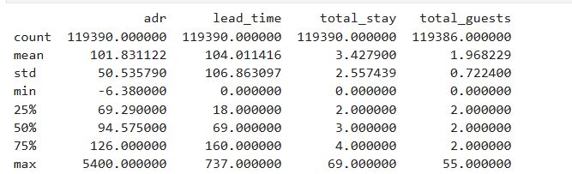
A correlation analysis was conducted to examine the relationships between the variables. The results showed that the number of guests had a moderate positive relationship with ADR (r = 0.368), indicating that bookings with more guests tend to have higher daily rates. This suggests that occupancy-related factors play an important role in pricing decisions.
Table 2. Correlation Matrix
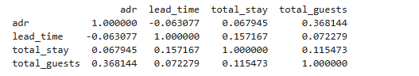
The relationship between ADR and length of stay was very weak (r = 0.067), indicating that the number of nights stayed does not strongly influence pricing. Similarly, lead time showed a weak negative relationship with ADR (r = -0.063), suggesting that booking timing has limited influence on pricing when analyzed independently.
A histogram of ADR was created to visualize its distribution. The results show that ADR is right-skewed, with most values concentrated at lower price levels and a small number of very high values. This indicates that while most bookings fall within a typical price range, higher-priced bookings occur under certain conditions, such as periods of high demand or when premium services are offered.
Figure 1. Distribution of Average Daily Rate (ADR)
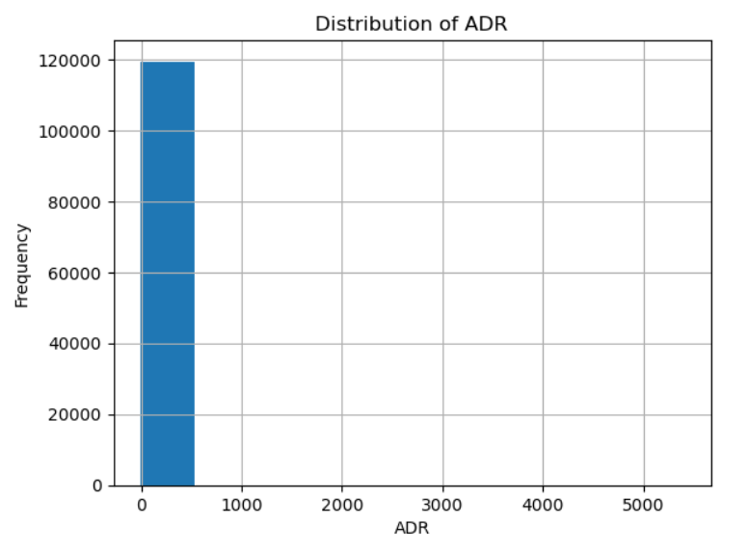
To further evaluate the combined effects of the variables, a multiple linear regression model was applied. The results showed that the overall model was statistically significant (p < 0.001), with an R-squared value of 0.145, indicating that the model explains approximately 14.5% of the variation in ADR.
The number of guests had the strongest positive effect on ADR (β = 25.91, p < 0.001), suggesting that pricing increases as the number of guests increases. Lead time showed a statistically significant but very small negative effect (β = -0.045, p < 0.001), indicating that earlier bookings are associated with slightly lower prices. Length of stay also had a statistically significant but small positive effect (β = 0.796, p < 0.001).
These results highlight that statistical significance does not always translate into a strong practical impact. While lead time and length of stay were statistically significant, their relatively small coefficients indicate that their influence on pricing decisions is limited in real-world applications.
The relatively low R-squared value suggests that a large portion of the variation in ADR is not explained by the variables included in this model. This reinforces the idea that hotel pricing is influenced by multiple factors, including external conditions such as market competition, location, and seasonal demand patterns.
Overall, the findings indicate that hotel pricing is influenced by a combination of factors, with guest-related variables having a more noticeable effect than booking behavior variables. These results support the need for more comprehensive models that incorporate additional variables to better understand pricing decisions.
Figure 2. Regression Results (OLS Model)
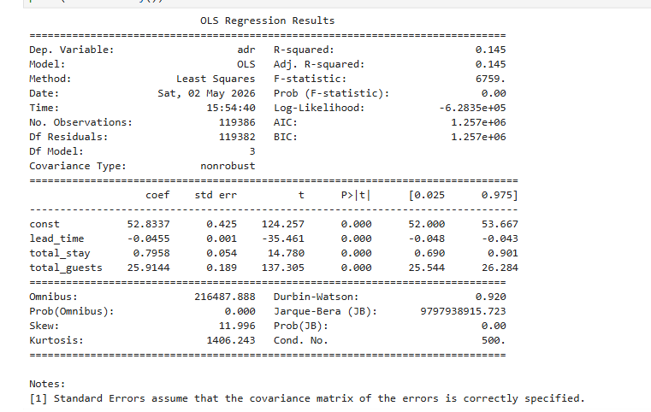

HYPOTHESIS TESTING RESULTS
Based on the analysis, the findings provide support for several of the proposed hypotheses. The purpose of this section is to evaluate each hypothesis using the results from both correlation and regression analysis to determine whether the variables have a significant effect on Average Daily Rate (ADR).
The number of guests showed a strong and statistically significant positive relationship with ADR. Both the correlation analysis (r = 0.368) and regression results (p < 0.001) indicate that as the number of guests increases, ADR also increases. Therefore, the null hypothesis for the number of guests is rejected, as there is sufficient evidence to conclude that this variable significantly affects ADR.
For lead time, the correlation analysis showed a very weak negative relationship with ADR (r = -0.063). However, the regression analysis indicated that lead time is statistically significant (p < 0.001), although the effect size is very small. Therefore, the null hypothesis for lead time is rejected based on statistical significance, but the results suggest that lead time has limited practical impact on pricing.
Similarly, the relationship between length of stay and ADR was very weak based on correlation (r = 0.067). However, the regression analysis showed that length of stay is also statistically significant (p < 0.001), with a small positive effect. As a result, the null hypothesis of no effect on length of stay is rejected, although the effect on pricing is minimal in practice.
Seasonal demand was not directly tested in the statistical analysis due to the structure of the dataset. Therefore, the null hypothesis for seasonal demand cannot be fully evaluated in this study. Additional analysis using time-based variables, such as month or season, would be required to properly test this hypothesis. The results indicate that while all tested variables are statistically significant, their practical impact varies. The number of guests has the strongest influence on ADR, while lead time and length of stay have much smaller effects. These findings highlight the importance of distinguishing between statistical significance and real-world impact when interpreting results.
These results also reinforce the value of data-driven analysis in testing assumptions. While some variables are commonly believed to influence pricing, their actual effect may be limited when examined in a statistical model. This emphasizes the need for comprehensive analysis when evaluating pricing strategies.
CONCLUSION
This study examined the factors that influence Average Daily Rate (ADR) using a data-driven approach based on hotel booking data. The purpose was to better understand how variables such as seasonal demand, booking lead time, length of stay, and number of guests affect pricing decisions in the hospitality industry. By applying descriptive statistics, correlation analysis, and multiple linear regression, the study provided insight into both the individual and combined effects of these variables on ADR.
The results showed that not all variables contribute equally to pricing decisions. The number of guests demonstrated the strongest and most meaningful effect on ADR, indicating that occupancy-related factors play a key role in determining pricing. In contrast, lead time and length of stay were found to be statistically significant but had relatively small effects, suggesting that their practical impact on pricing is limited. These findings highlight the importance of distinguishing between statistical significance and real-world relevance when interpreting results.
Another important observation is that ADR is not evenly distributed, as shown by the right-skewed histogram. Most bookings fall within a lower price range, while a smaller number of bookings have significantly higher rates. This suggests that pricing is influenced by specific conditions such as peak demand periods, special events, or premium services, which can lead to higher ADR values for certain bookings.
The relatively low R-squared value of the regression model indicates that a large portion of the variation in ADR is not explained by the variables included in this study. This reinforces the idea that hotel pricing is a complex process influenced by multiple factors, including external variables such as location, competition, customer segmentation, and broader market conditions. As a result, no single variable can fully explain pricing behavior.
These findings have important practical implications for the hospitality industry. By identifying which variables have stronger or weaker effects on pricing, hotel managers can make more informed decisions when adjusting rates and align pricing strategies with actual demand patterns rather than relying solely on assumptions or past experience. This can lead to more consistent and effective pricing decisions over time and improve overall revenue management performance.
In addition, the results highlight the importance of continuously updating and evaluating pricing models. As market conditions, customer preferences, and travel behaviors change, pricing strategies must adapt accordingly. Organizations that regularly analyze their data and refine their models are more likely to remain competitive and responsive to fluctuations in demand.
The study also emphasizes that even relatively simple statistical models can provide valuable insights when applied correctly. While more advanced techniques may improve predictive accuracy, the use of regression analysis in this study demonstrates that meaningful conclusions can still be drawn from structured data using fundamental analytical methods.
Overall, this study demonstrates that data analysis can provide valuable insights into hotel pricing behavior and support more effective, data-driven decision-making. At the same time, it highlights the need for more comprehensive models and additional variables to fully understand the complexity of pricing strategies. Future research should continue to explore these factors to improve the accuracy and usefulness of pricing models in the hospitality industry.
These findings also reinforce the importance of adaptability in pricing strategies within the hospitality industry. As market conditions, customer behavior, and travel trends continue to evolve, hotels must remain flexible in how they adjust pricing models. Relying on static pricing approaches may limit revenue potential, while data-driven and adaptive strategies can help organizations respond more effectively to changing demand patterns. By continuously monitoring performance and updating pricing models, hotels can improve both short-term profitability and long-term competitiveness.
RECOMMENDATIONS
Based on the findings of this study, several recommendations can be made to improve hotel pricing strategies and support more effective decision-making. Hotels should place greater emphasis on guest-related factors, particularly the number of guests, when developing pricing models. Since this variable showed the strongest effect on ADR in both correlation and regression analysis, it suggests that occupancy levels and room demand play a key role in determining pricing. Adjusting pricing strategies to better reflect guest demand may help optimize revenue.
Hotels should expand the use of data-driven pricing systems. While traditional pricing decisions are often based on experience, this study highlights the value of using statistical analysis to identify patterns and relationships. Implementing more advanced revenue management systems that leverage real-time data could improve pricing accuracy and enable hotels to respond more effectively to demand fluctuations.
Another recommendation is to include additional variables in future analysis. The results showed that lead time and length of stay had a limited practical impact on ADR, which suggests that other factors may be more important. Variables such as location, hotel type, customer segmentation, and seasonal demand indicators could provide a more complete understanding of pricing behavior and improve the predictive power of future models.
It is also recommended that hotels regularly review and validate their data to ensure accuracy. Data quality issues, such as missing values or outliers, can affect analysis results and lead to incorrect conclusions. Establishing consistent data-cleaning and validation processes can improve the reliability of pricing models and support better decision-making.
Finally, future research should explore the use of more advanced analytical techniques, such as expanded regression models or machine learning approaches, to better capture the complexity of hotel pricing. These methods could provide deeper insights into how different factors interact and influence ADR.
Hotels should also consider integrating predictive analytics into their pricing strategies. By using historical data and forecasting techniques, hotels can anticipate future demand trends and adjust pricing proactively rather than reactively. This approach can help improve revenue management by allowing hotels to respond more effectively to changes in demand.
In addition, organizations should invest in training staff to understand and interpret data-driven insights. While advanced systems can generate valuable information, the ability to interpret and apply these insights effectively is essential for successful decision-making. Developing these skills can enhance the overall effectiveness of pricing strategies.
Another important recommendation is to encourage collaboration between data analysts and management teams within hotel organizations. While data analysis can provide valuable insights, these insights are most effective when combined with industry knowledge and operational experience. By working together, analysts and decision-makers can ensure that pricing strategies are both data-driven and practical. Hotels should consider implementing systems that allow for continuous performance monitoring. Tracking key performance indicators such as ADR, occupancy rates, and revenue over time can help organizations evaluate the effectiveness of their pricing strategies and make adjustments when necessary. This ongoing evaluation process can improve long-term decision-making and support sustained revenue growth.
These recommendations emphasize the importance of combining data analysis with practical decision-making. By adopting a more structured, data-driven approach, hotels can improve pricing strategies, enhance revenue performance, and better adapt to changing market conditions.
REFERENCES
Colorado State University Global. (n.d.). Business Intelligence and Data Analytics. https://csuglobal.instructure.com/courses/117454/pages/3-dot-1-data-analytics-types?module_item_id=6233426
Hargrave, M. (2026, March 2). Understanding Average Daily Rate (ADR): Definition, Calculation, and Examples. Investopedia. https://www.investopedia.com/terms/a/average-daily-rate.asp
Ivanov, S., & Zhechev, V. (2012). Hotel revenue management: A critical literature review. Tourism & Management Studies, 8, 175–197. https://www.researchgate.net/publication/228254814_Hotel_Revenue_Management_-_A_Critical_Literature_Review
Gao, J. (2025). Optimizing hotel revenue management through dynamic pricing algorithms and data analysis. Journal of Revenue and Pricing Management. https://journals.sagepub.com/doi/abs/10.1177/14727978241298467
Valli, L. N., Sujatha, N., Mech, M., & Lokesh, V. S. Ethical considerations in data science: Balancing privacy and utility. International Journal of Science and Research Archive, 11(1), 011–22. https://doi.org/10.30574/ijsra.2024.11.1.1098
James, G., Witten, D., Hastie, T., Tibshirani, R., Taylor, J. (2023). An Introduction to Statistical Learning. Springer, Cham. https://doi.org/10.1007/978-3-031-38747-0_2

